Importing Data from a Website using Power Query
- Step-by-Step Process:
- Visit the Website:
  - Open your web browser and go to the website from which you want to import data (e.g., Worldometer).
  - Copy the URL from the address bar.
- Open Excel Workbook:
  - Launch Microsoft Excel.
  - Open a blank workbook or an existing one.
- Navigate to the Data Tab:
  - Click on the Data tab in the ribbon.
  - Select From Web under the Get & Transform Data section.
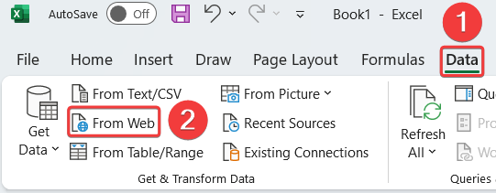
- Paste the URL:
  - A dialog box will appear.
  - Importing data form Website URL: https://research360.in/fii-dii-activity/fiicash-monthlyC
  - Paste the copied website URL into the box and click OK.


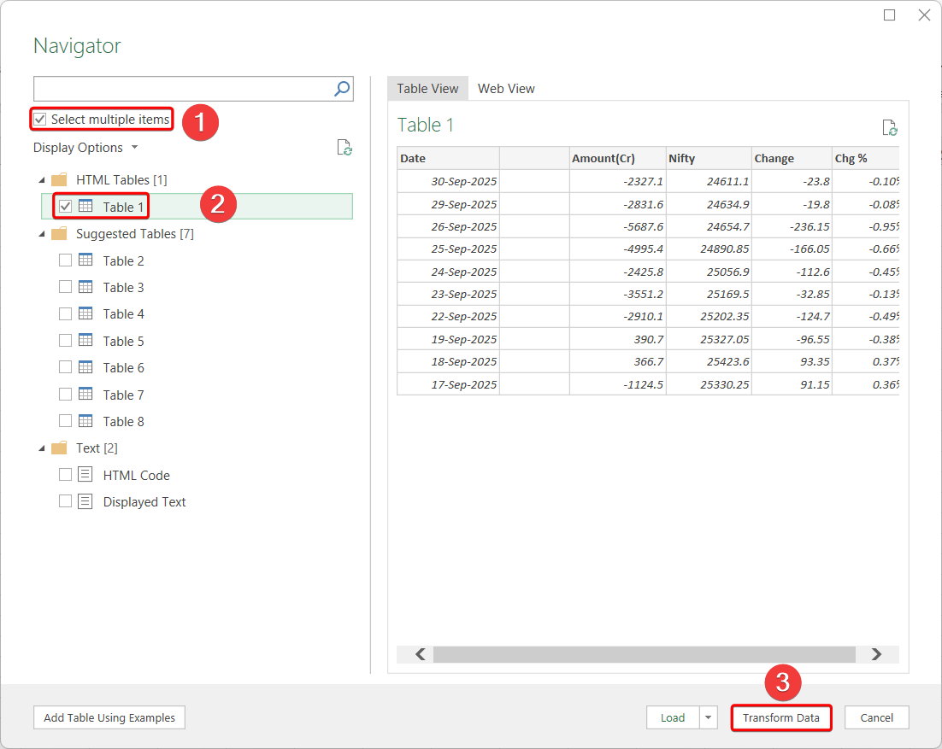
- Load Data through Power Query:
  - Power Query will connect to the website and display a Navigator Pane with all available tables on the web page.
  - You will see a preview of each table.
- Select Table(s):
  - Choose the relevant table (or multiple tables) you want to import.
  - Click on Transform Data if you want to modify the data before importing.
- Transform the Data (Optional but Recommended):
  - Use Power Query Editor to:
    - Remove blank rows
    - Remove duplicate entries
    - Rename columns
    - Change data types
    - Filter rows
    - Clean the data as needed

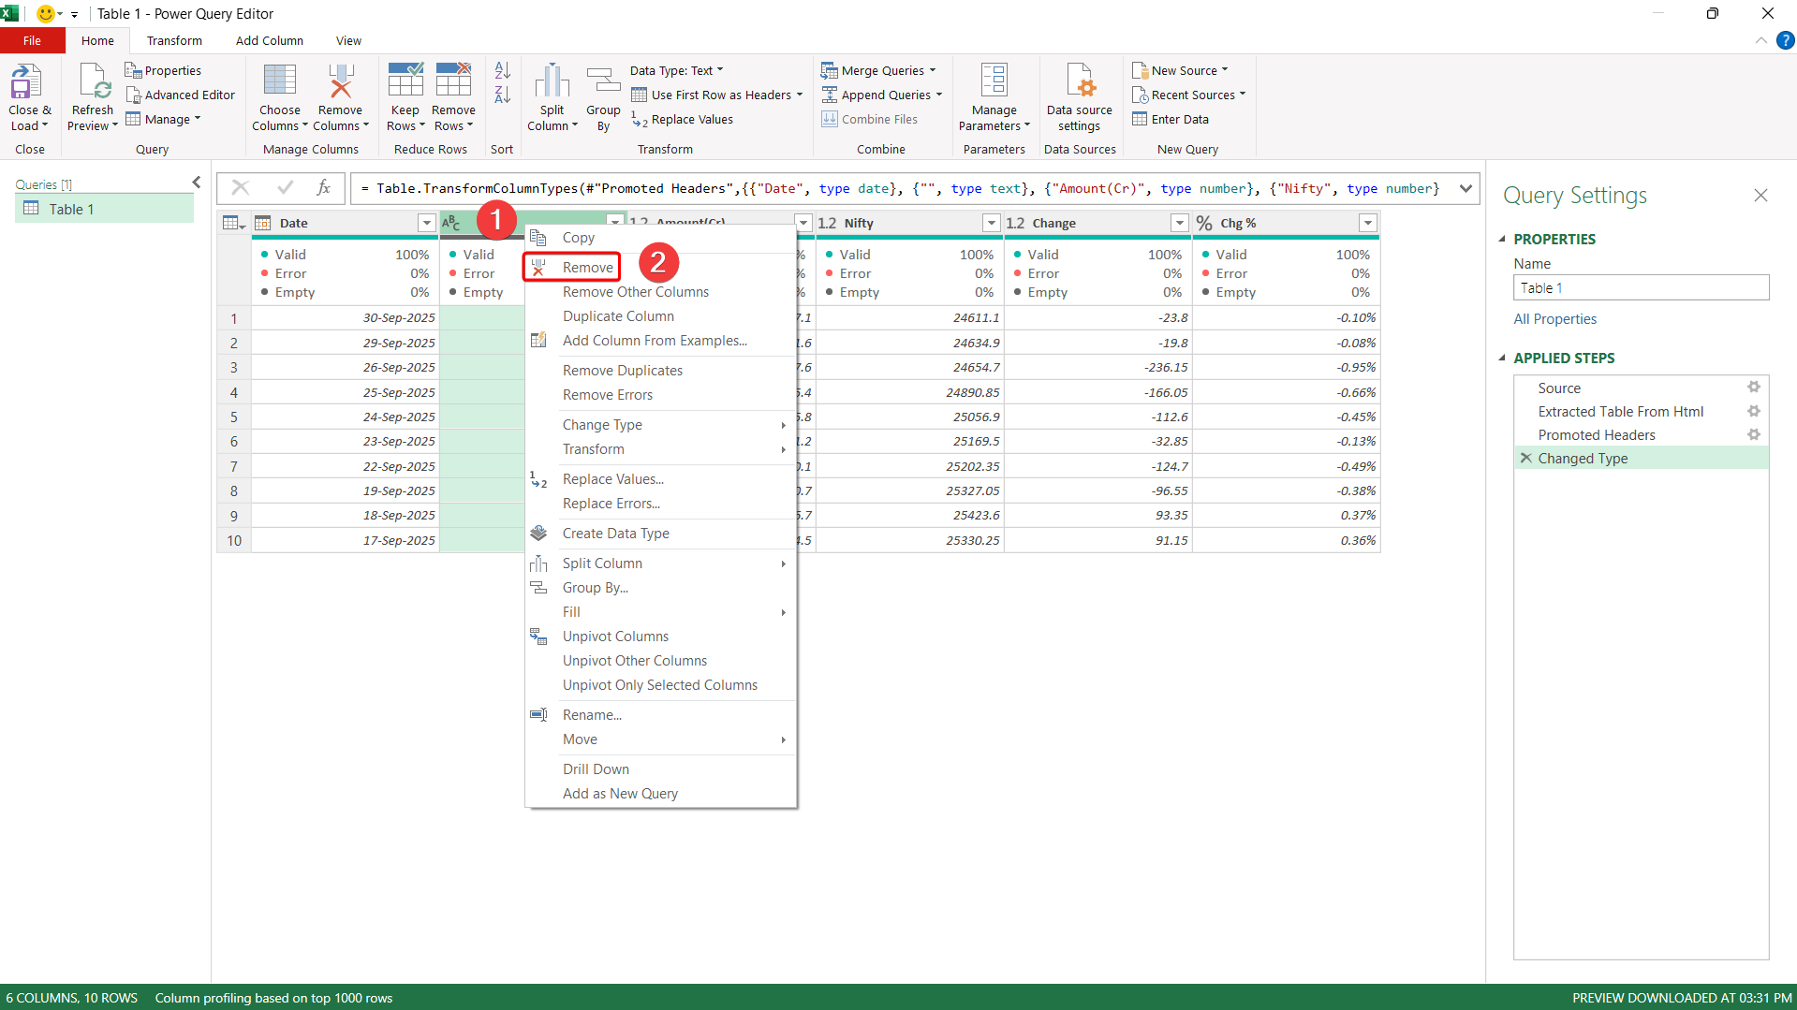
- Load the Data:
  - Once satisfied with the transformation, click on:
    - Close & Load – to load the data into Excel.
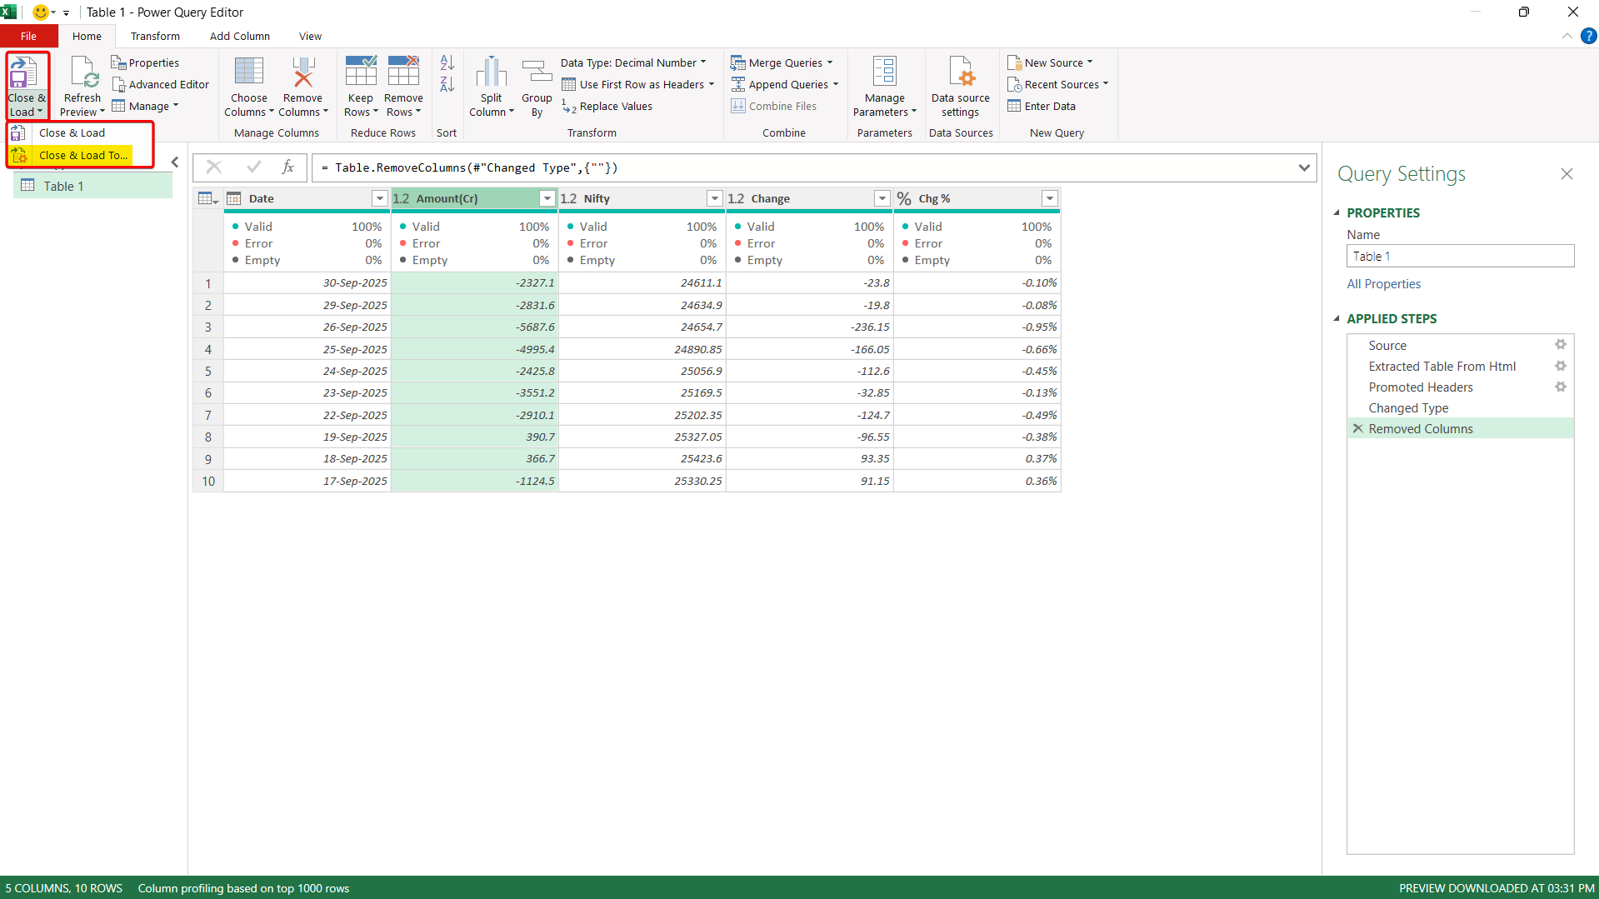

- Last Action – Once Data cleaning done – Click on Home Tab Close and Load To – which helps you to load data in Table, Pivot Table, Pivot Charts and Queries Connections.

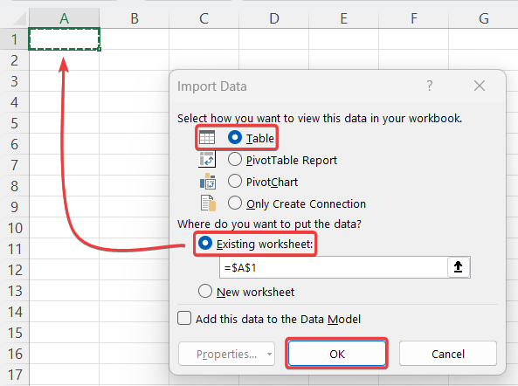

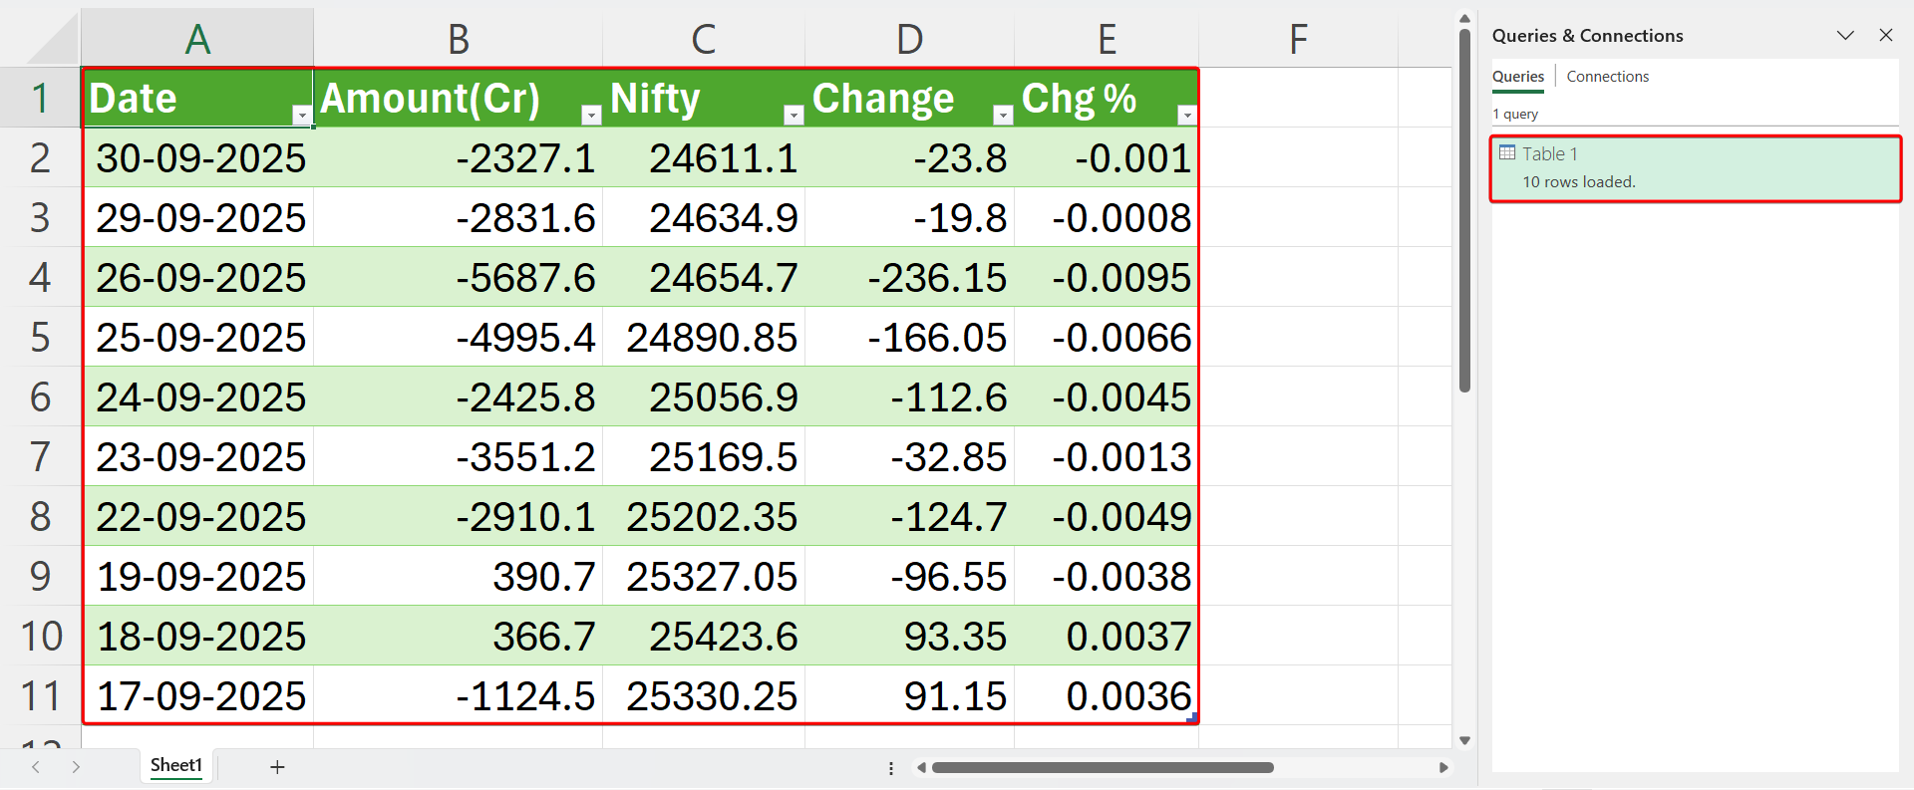
Key Features and Benefits:
Feature | Description
Live Data Refresh | The imported data can be refreshed automatically when the source website updates.
Web Table Detection | Power Query automatically detects HTML tables from web pages.
Data Cleaning Tools | Provides tools for data transformation like removing nulls, changing types, filtering, etc.
Reusable Queries | Queries can be saved and reused whenever needed.
Tips:
- Not all websites support structured table import. Prefer websites that display data in HTML tables.
- If the page uses JavaScript to load data, Power Query might not detect those tables.
- You can schedule data refresh or manually refresh via Data > Refresh All.
Step-by-Step: Importing Data from an Image
- Step-by-Step Process:
- Prepare the Image File:
  - Make sure your image contains a clear and structured table.
  - Save the image in a supported format like .jpg, .png, or .bmp.
- Open Excel Workbook:
  - Start Excel and open a new or existing workbook.
- Go to the Data Tab:
  - In the ribbon, click on the Data tab.
  - Choose From Picture > Picture From File.
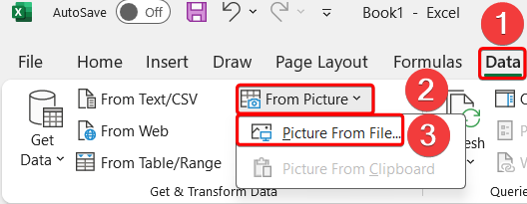
- Select the Image:
  - A file dialog will open.
  - Locate and select the image file you want to import.
- OCR Processing:
  - Excel will use OCR to analyse and convert the image into text-based table data.
  - A preview pane will appear with the extracted data.
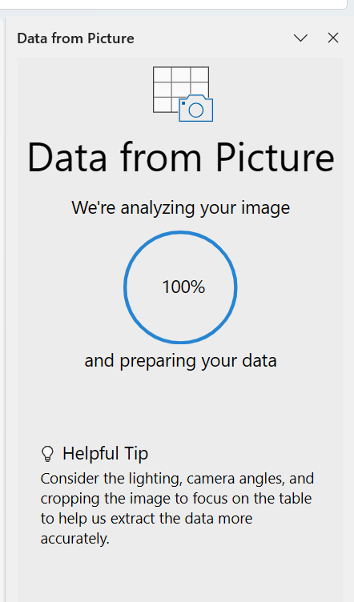
- Review and Edit the Data:
  - You can make corrections if OCR misread any values (common in blurry or handwritten text).
  - Make sure column headers and row values are correctly aligned.
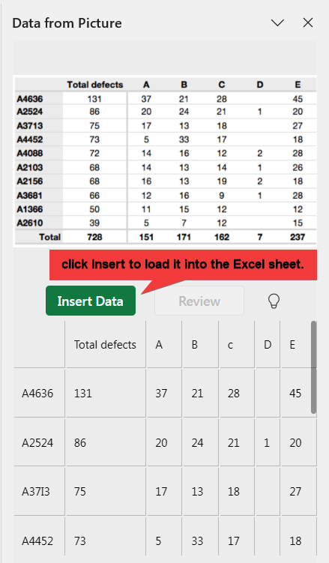

Step-by-Step: Importing Data from a PDF
- Step-by-Step Process:
- Open the PDF File:
  - Make sure you have the PDF file with the data (tables) you want to import.
  - Keep it saved locally on your computer.
- Open Excel Workbook:
  - Launch Microsoft Excel and open a blank or existing workbook.
- Go to the Data Tab:
  - Click on the Data tab in the Excel ribbon.
  - Select From PDF under the Get & Transform Data group.
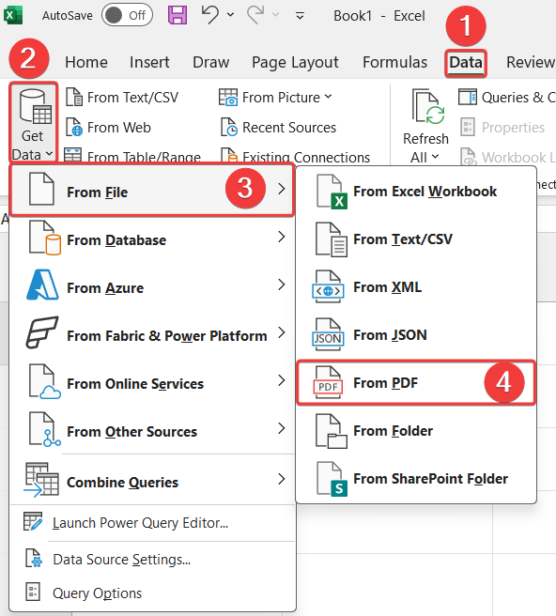
- Select the PDF File:
  - Browse your computer to locate the PDF file.
  - Select the file and click Import.
- Navigator Preview Window:
  - Power Query will scan the PDF and display a list of tables and pages it detects.
  - Select the table(s) you want to extract. You can click on each to preview it.
- Clean and Transform Data (Optional):
  - Click on Transform Data to open the Power Query Editor.
